|  |
| --- |
| College LaSalle |
| Project - Oriented Object Programming User and Technical Manual |
|  |
| Presented to: Mihai Maftei. |

|  |
| --- |
| Your name: Yasser Bousrih  3/28/2023  Version: 2.0 |

1. **Start by adding a short description of your project, and the languages (technologies) used:**
2. Language: windows forms
3. Tools (IDE): visual studio
4. **Present the print screens of yours forms, and have a detailed description of the functionalities (step by step).**

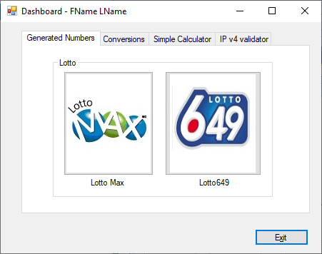

1. If you click on lotto max
2. You will open form 2
3. If you click on the Exit button, it hides form 2
4. **Present the code of your application (forms).**

… your code goes here

1. **Present the classes and/or methods that you create or you did use in the project.**

|  |  |
| --- | --- |
| **Class/Method Name** | **Description** |
| 1. Form2 | Form2 |
| 1. Class2 | Enter a short description of the class or of the method ……………….. |
| 1. void Method(int total) | Enter a short description of the class or of the method ……….. |
|  |  |
| 1. Constructor() | Enter a short description of the class or of the method ………… |

1. **Present the difficulties that you have, what was the hardest and the easiest part of your project.**

… your presentation goes here …